## EE Decoding algorithm

## Extended Euclidean algorithm basic

see Todd K. Moon, *Error Correction Coding: Mathematical Methods and Algorithms*, section 5.2.2

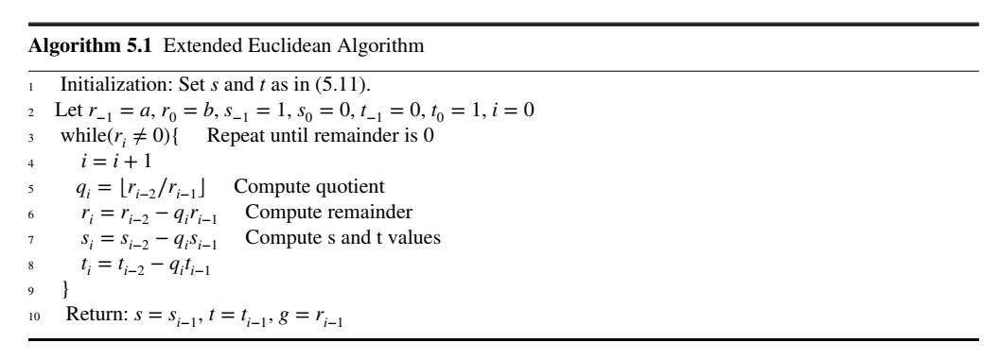

EEA is used to find the GCD of polynomials a(x) and b(x), which also satisfies:



Then compare the key equation to upper equation:

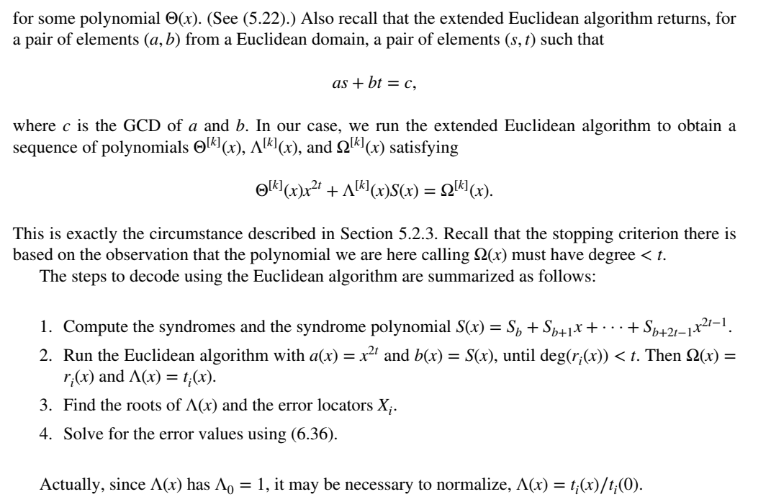

## Decoder Architectures

The realization of EEA uses same modules as BMA (see Zhang Xinmiao, *VLSI architectures for modern error-correcting codes*, section 4.3.4 and 4.3.5). The differences are those procedures about recursive remainder calculation.

## Complexity Analysis

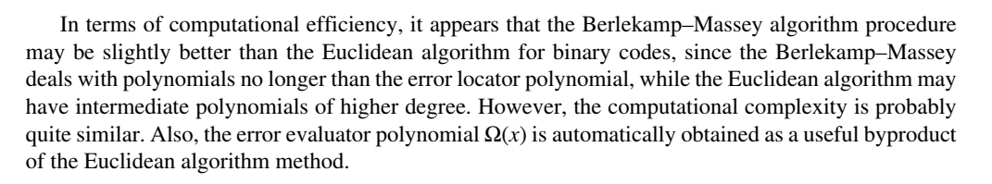

And the iteration times should be considered.

## Example

